

MUSIC RECORD DATABASE

**Submitted By:**

|  |  |
| --- | --- |
| **Sarthak Bajaj** | **19BCE0710** |
| **Khushi Agrawal** | **19BCE0418** |
| **Aviral Goyal** | **19BCE0883** |

Under the Guidance of,

PROF. NITHYA S.

ER-DIAGRAM

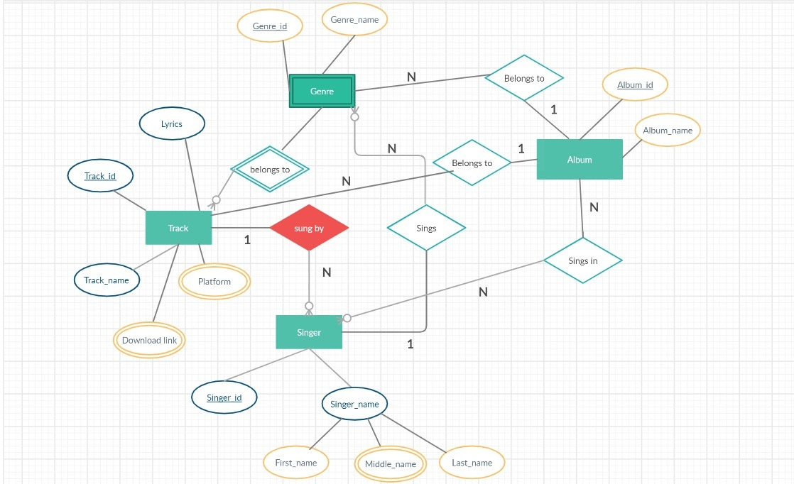

RELATIONAL SCHEMA

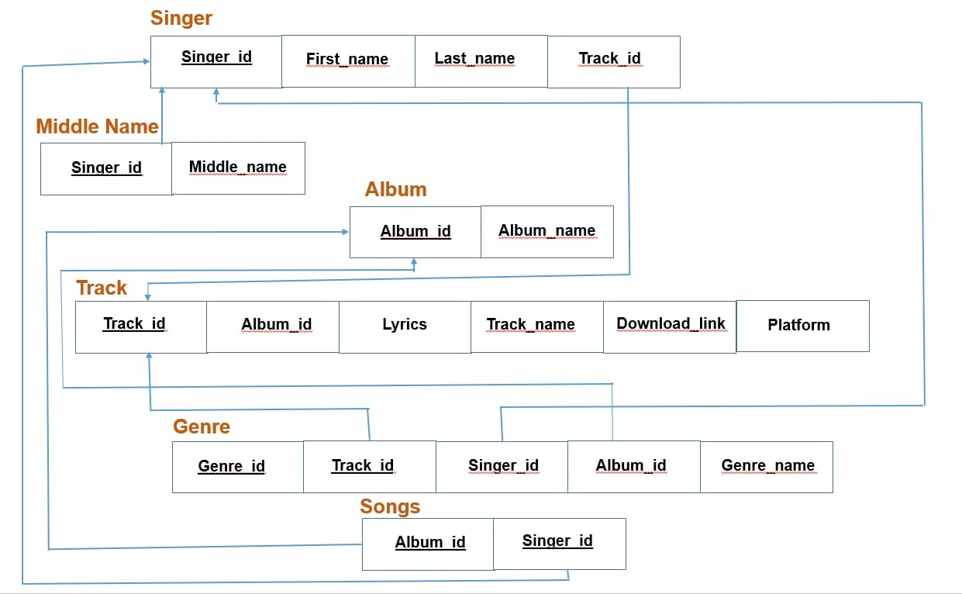

DATA COLLECTION

* Format- album, song, (lyricist), (singer), (genre), lyrics link, download link

1. Anjaana Anjaani, Hairat, (Vishal Dadlani), (Lucky Ali), () , <http://www.lyricsoff.com/songs/hairat.html>, <https://www.pendujatt.net/hindi-songs/song/hairat-hai-hairat-hai-lucky-ali-lmw.html>
2. Anjaana Anjaani, Aas Paas Khuda, (Vishal Dadlani and Shekhar Ravjiani), (Rahat Fateh Ali Khan), <http://www.lyricsoff.com/songs/aas-paas-hai-khuda-anjaana-anjaani.html>, <https://www.pendujatt.net/hindi-songs/song/aas-pass-hai-khuda-rahat-fateh-ali-khan-lmr.html>
3. Anjaana Anjaani, Tumse Hi Tumse, (Amitabh Bhattacharya and Anvita Dutt Guptan), (Shekhar Ravjiani and Caralisa Monteiro), <http://www.lyricsgram.com/song/tumse-hi-tumse-2708>, <https://www.mr-jatt.im/latest-music/song/61827/Tumse-Hi-Tumse-Anjaana-Anjaani-Various-mp3-song.html>
4. Anjaana Anjaani, Tujhe Bhoola Diya,  (Kumaar and Vishal Dadlani) , (Mohit Chauhan, Shekhar Ravjiani and Shruti Pathak), (Romantic, sad), <http://www.lyricsoff.com/songs/tujhe-bhula-diya.html>, <https://www.pendujatt.net/hindi-songs/song/tujhe-bhula-diya-mohit-chauhan-shekhar-ravjiani-shruti-pathak-ajmvx.html>
5. Anjaana Anjaani, I Feel Good, (Vishal Dadlani), (Vishal Dadlani and Shilpa Rao), (love), <https://www.lyricsbogie.com/i-feel-good/>, <https://www.pendujatt.net/hindi-songs/song/i-feel-good-teri-meri-vishal-dadlani-shilpa-rao-lnm.html>
6. Anjaana Anjaani, Anjaana Anjaani Ki Kahaani, (Neelash Misra), (Nikhil D’Souza and Monali Thakur), (<Romantic>,[Happy](https://www.pendujatt.net/hindi-songs/mood/happy.php),[Dance](https://www.pendujatt.net/hindi-songs/mood/dance.php),[Party](https://www.pendujatt.net/hindi-songs/mood/party.php)), <http://www.lyricsoff.com/songs/anjaana-anjaani.html>, <https://www.pendujatt.net/hindi-songs/song/anjaana-anjaani-ki-kahani-monali-thakur-nikhil-d-souza-lmt.html>
7. Dangal, Haanikaarak Bapu, ([Amitabh Bhattacharya](https://www.lyricsmint.com/amitabh-bhattacharya)), (Sarwar Khan, Sartaz Khan Barna, Saddy Ahmad), <https://lyricsily.com/lyrics/hanikarak-bapu-lyrics-dangal-aamir-khan>, <https://www.pendujatt.net/hindi-songs/song/haanikaarak-bapu-sarwar-khan-sartaz-khan-barna-amiva.html>
8. Dangal, Dhaakad, (Amitabh Bhattacharya), (Raftaar), (Hip-Hop, Rap), <https://www.lyricsmint.com/dangal/dhaakad>, <https://www.pendujatt.net/hindi-songs/song/dhaakad-raftaar-amorj.html>
9. Dangal, Gilehriyaan, (Amitabh Bhattacharya),  (Jonita Gandhi), <https://www.lyricsmint.com/dangal/gilehriyaan>, <https://www.pendujatt.net/hindi-songs/song/gilehriyaan-jonita-gandhi-ammxt.html>
10. Dangal, Dnagal, (Amitabh Bhattacharya), (Daler Mahendi), <https://www.lyricsmint.com/dangal/dangal-title-track>, <https://www.pendujatt.net/hindi-songs/song/dangal-daler-mehndi-dshfq.html>